Sahil Gawande

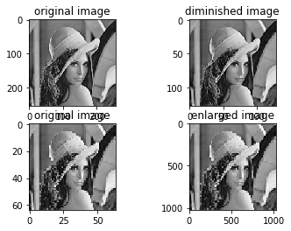

B05

2016bec006

import numpy as np

import cv2

import matplotlib.pyplot as plt

img = cv2.imread(r"D:\Btech practicals\DIP\lena_256.jpg",0)

zoomed_img = np.zeros([1024,1024])

small_img = np.zeros([len(img)//2,len(img)//2])

l=0

for i in range(0,len(img),2):

m=0

for j in range(0,len(img),2):

small_img[l][m] = img[i][j]

m+=1

l+=1

plt.subplot(221)

plt.title("original image")

plt.imshow(img,cmap='gray')

plt.subplot(222)

plt.title("diminished image")

plt.imshow(small_img,cmap='gray')

img = cv2.imread(r"D:\Btech practicals\DIP\lena_64.jpg",0)

l=0

m=0

counter = 0

k = 0

increase = np.zeros(1024)

for j in range(len(img)):

for i in range(len(increase)):

increase[i] = img[l][m]

counter+=1

if(counter==(1024//len(img))):

m+=1

counter = 0

if(m==len(img)):

for b in range(1024//len(img)):

zoomed_img[k+b] = increase

increase = np.zeros(1024)

l+=1

m=0

k+=1024//len(img)

plt.subplot(223)

plt.title("original image")

plt.imshow(img,cmap='gray')

plt.subplot(224)

plt.title("enlarged image")

plt.imshow(zoomed_img,cmap='gray')

